Research Project for 11th English – Mrs. Russell

OBJECTIVE: Write a literary analysis over F. Scott Fitzgerald’s novel, “The Great Gatsby”.

THIS ASSIGNMENT IS DUE 11/19-11/20 AND CAN BE TURNED IN BEFORE OR DURING THOSE DAYS BUT NOT AFTER. STUDENTS MUST TURN IN THEIR PROJECT ELECTRONICALLY ON EDMODO. IF YOU ARE LEAVING EARLY FOR THANKSGIVING BREAK, PLEASE HAVE EVERYTHING TURNED IN ONLINE BY 11/20. STUDENTS MUST ALSO TURN IN ONE RESEARCH ENVELOPE INCLUDING: PRINTED OUT COPY OF ALL 5 PAGES AND NOTECARDS. TECHNOLOGY ISSUES AT MIDNIGHT ON THE LAST NIGHT WILL NOT EXCUSE YOU FROM DEADLINES.

CHECKLIST for DUE DATE (11/19-11/20)
- PROJECT UPLOADED TO EDMODO IN ONE DOCUMENT – 47hc4y
- PRINTED COPY
  - Page 1 – OUTLINE (200 points)
  - Pages 2 – 4 PAPER (200 points)
  - Page 5 – BIBLIOGRAPHY (200 points)

Mon | Tues | Wed | Thurs | Fri
10/29 | 10/30 | 10/31 | 11/1 | 11/2
Not a SCHEDULED research day. | Rules & Stuff, Intro to Research Unit & Rubrics | Introduction to Online Researching Techniques | Brainstorming & Intro To Research & MLA handbooks & Outlining | Taking Notes & Parenthetical Documentation
11/5 | 11/6 | 11/7 | 11/8 | 11/9
Research Week – You will locate 4 sources to document: 1 book, 2 online newspaper/online journals, and 1 website. This week we will start the research project.
ALL NOTECARDS (200 points) ARE DUE BY FRIDAY, 11/9 AND WILL BE CHECKED AND RETURNED SAME DAY TO STUDENTS TO USE WHILE WRITING.
11/12 | 11/13 | 11/14 | 11/15 | 11/16
HOLIDAY | WRITING WEEK – This is the week that we will write, re-write, & edit! Please have all articles, book you have checked out, notecards, and etc. We will have the mobile lab Tuesday – Thursday.
11/19 | 11/20 | 11/21 | 11/22 | 11/23
Your paper is due on EDMODO before you leave on 11/20 – NO EXCEPTIONS! |  | Thanksgiving Holidays

It will take me up to one hour to grade each project and I will have about 67 to grade. Remember, I have to grade each individual card and check the sources that you have used in your paper (parenthetical documentations). I have to check your paper, outline, and bibliographies. I have to locate your sources and compare them to your paper (hoping to NOT find any plagiarized lines). It takes a LONG TIME so please be patient with me. It took you three weeks to write so it will take me just as long to grade. I will post grades at the same time because it’s not fair for some students to know their grades and others to not know their grades.

You will be responsible for:
- Researching your topic and locating sources – Laptops for 4 days to type and iPads 4 days to research.
- Typing a 3 page paper – double-spaced, 12 point, Times New Roman, MLA, & 1” margin
- 20 Notecard minimum
- Outline (SAME MLA FORMATS AS PAPER)
- Bibliography (SAME MLA FORMATS AS PAPER)

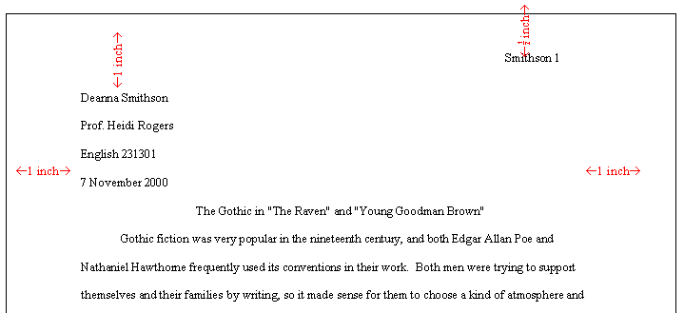
The Actual Paper

Please indent your paragraph and begin typing your text. Double-space at the end of each sentence. Do not use “I” but write in 3rd person, please. You should also double-space your entire paper. If you don’t know how to double-space, please follow these instructions and see picture below: Hit CTRL+A (which highlights everything). Click on the double-space icon and then select 2.0. Your paper will be a minimum of 5 paragraphs. You will have an introduction (paragraph 1), theme (paragraph 2), character analysis (paragraph 3), writing style – one of your (see the back wall in our room) literary terms (paragraph 4), and a conclusion (paragraph 5). Paragraph 1 will begin with a thesis statement. The paper will be written in 3rd person and present or past tense (1 but not both).
- Always refer to your subject by last name.
  - Be sure to use parenthetical documentation for all quotes and summaries! (Russell, 84).
- For longer quotes (4+ lines), frame with single spacing and pull in margins. Don’t use quotation marks and cite at the end.
- Use ellipses … for long quotations.
- No contractions or abbreviations. Can’t = cannot
- Only cite sources you quote/summarize.
- Don’t cut and paste anything. NO PLAGARISM. Papers that are plagiarized will be given a zero and will not have an opportunity to re-do. I would rather you write poorly than cheat!
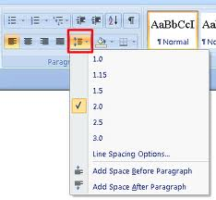
- Short works = short lines (quotes) and Long works = long lines (underlines).

If you need additional help, use the research manuals in the classroom or one of these websites:
http://www.bartleby.com/141/strunk.html
http://www.reference.com/browse/all/
http://www.bibliomania.com/2/3/frameset.html
http://books.google.com/
http://www.avl.lib.al.us/
http://www.edmodo.com/
http://owl.english.purdue.edu/owl/search2.php

PAPER - 1=weak 2=moderately weak 3=average 4=moderately strong 5=strong
1). Paragraph in the assignment starts with a topic sentence. | 1 | 2 | 3 | 4 | 5
2). The organization of the writing assignment is clear and easy to follow. | 1 | 2 | 3 | 4 | 5
3). The assignment is concise and well written. | 1 | 2 | 3 | 4 | 5
4). The assignment employs the appropriate information or facts. | 1 | 2 | 3 | 4 | 5
5). The content demonstrates an understanding of the topic and related concepts. | 1 | 2 | 3 | 4 | 5
6). The spelling, punctuation, and grammar on the writing assignment are accurate. | 1 | 2 | 3 | 4 | 5
8). If appropriate, the assignment appears to have been well researched. | 1 | 2 | 3 | 4 | 5
9). The content fulfills all the requirements of the assignment. | 1 | 2 | 3 | 4 | 5
10). Overall, the work represents the writer's full potential. | 2 | 4 | 6 | 8 | 10

FAIL PROOF THESIS WRITING
I know it is 2012 and other more current social media websites are available but this was true in 2005! So how do you write a thesis? For that matter, what is a thesis anyway? A thesis is your controlling idea. It’s what every paragraph points back to. It’s what every sentence provides an example for. It’s your main idea that keeps you focused to write a paper over one topic rather than many topics.
Directions: I want you to read the 7 questions and the answers that I have provided. Once you have all your answers you can re-order the responses to make one statement that says all the things you want to say but in a clever way [see the final thesis at the bottom]. After you read my questions and answers I want you to answer the questions for your topic too! Re-order your answers and see what kind of sentence you come up with. It may not make sense at first but it is something we can work with. This is the starting point of your paper and everything you write about points directly back to the thesis statement. It’s the most important sentence you write!
- What's the topic you want to write about?
MySpace

- What's your main opinion on this topic?
MySpace can be a dangerous place for teenagers

- What's the strongest argument supporting your opinion?
Sexual predators use the internet to troll for victims
- What's a second good argument that supports your opinion?
They [students] list too much personal information on the internet
- You could list a third, fourth, and fifth argument here that supports your opinion. If you can combine all five into one or two main arguments, that would be best!

- What's the main argument against your opinion?
MySpace is a website where teenagers can meet others like themselves
- What's a possible title for your Essay?
Is MySpace Safe?

Is MySpace Safe? ₇
Thesis: Even though MySpace is a website where teenagers can meet others like themselves₆, MySpace can be a dangerous place for teenagers₂ because they list too much personal information on the internet₄ and sexual predators use the internet to troll for victims₃.

OUTLINE

Outlines are to written first to keep you on the right track. These are words/phrases – not full sentences. Save the sentences for your paper. The outline is typed on a page all by itself. It is not included in the 3 page paper total.

- Introduction & Overview – INCLUDES THESIS
- THEME (PICK ONE-Decline of the American Dream, Society and Class, Love, Wealth, Memory and the Past, Dissatisfaction, Mortality, Isolation, Lies and Deceit, Compassion and Forgiveness, or Sacrifice)
- Explanation
- Examples (QUOTE OR SUMMARY)
- Conclude
- CHARACTER ANALYSIS (With ABC) (PICK ONE-Jay Gatsby, Nick Carraway, Tom Buchanan, George Wilson, Daisy Buchanan, Jordan Baker, or Myrtle Wilson)
- WRITING STYLE (With ABC) (PICK ONE-POV, Figurative Language, Symbolism, Flashback, Foreshadowing, Irony, or any other literary term that you can prove to me that you can easily identify and understand.
- Re-cap & Conclusion – RESTATES THESIS

OUTLINE 1=weak 2=moderately weak 3=average 4=moderately strong 5=strong
1). The organization of the outline is clear and easy to follow. | 2 | 4 | 6 | 8 | 10
2). The content demonstrates an understanding of the topic and related concepts. | 2 | 4 | 6 | 8 | 10
3). The spelling, punctuation, and grammar on the writing assignment are accurate. | 2 | 4 | 6 | 8 | 10
4). The assignment appears to have been well researched. | 2 | 4 | 6 | 8 | 10
5). Overall, the work represents the writer's full potential. | 2 | 4 | 6 | 8 | 10

Bibliography

A bibliography is a list of sources that you compiled to reference in your research paper. You must list the bibliographies alphabetically at the end of your paper. It’s often referred to as a “bib” or a “works cited” page. You may name it either “Bibliography” or “Works Cited”. THIS IS A SEPARATE PAGE and is not included in your paper 3 page total. You will locate 4 sources – see your calendar. NOTE: The bibliography is typed the same way as the outline page but lists your sources alphabetically AND in MLA format. It may end up being more than one page depending on how many sources your group used. Citation Machine – Helps create a bibliography page: http://tinyurl.com/bxeyk6

BIBLIOGRAPHY 1=weak 2=moderately weak 3=average 4=moderately strong 5=strong
1). Bibliography typed according to MLA formats. | 1 | 2 | 3 | 4 | 5
2) Alpha order | 1 | 2 | 3 | 4 | 5
3).Sources correctly listed in MLA format | 1 | 2 | 3 | 4 | 5
4).Verified Source #1 | 1 | 2 | 3 | 4 | 5
5) Verified Source #1 | 1 | 2 | 3 | 4 | 5
6) Verified Source #1 | 1 | 2 | 3 | 4 | 5
7) Verified Source #1 | 1 | 2 | 3 | 4 | 5
8).Fulfills all the requirements of the assignment | 1 | 2 | 3 | 4 | 5
9).Overall, the work represents the writer's full potential | 2 | 4 | 6 | 8 | 10

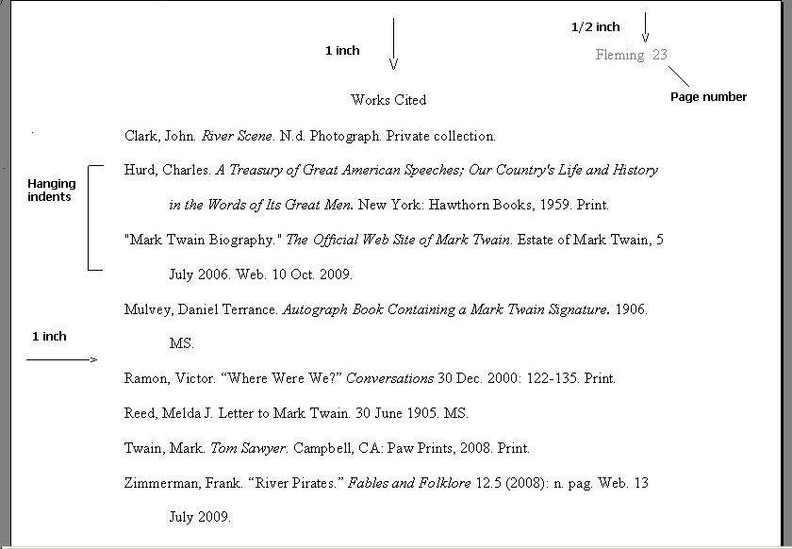
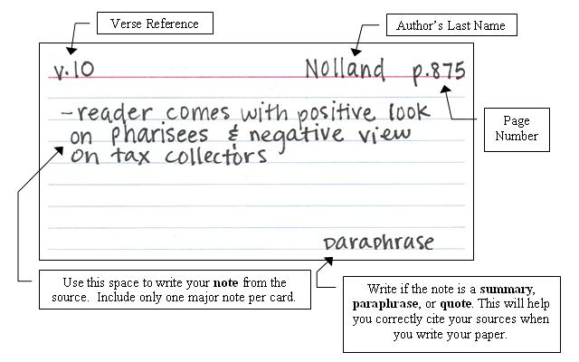
Notecards

Notecards are used during the research unit to copy quotes that help support your thesis. On notecards, you can record a specific quote, paraphrase, or summary. You are required to have 4 sources and a minimum of 5 cards per source. You are welcome to use more sources but each additional source cited in your paper must also have 5 notecards. Once all the cards are written, you will arrange them to see how they best fit in your paper. Some will be used and some will not. You must use at least 2 quotes, summaries, or paraphrases in paragraphs 2, 3, and 4 – FOR A TOTAL OF 6 parenthetical documentations. You are welcome to add a quote, summary, or paraphrase in paragraphs 1 and 5 but you still must have the required 6.

Other notes I need:
________________________________________________________________________________________________________________________________________________________________________________________________________________________________________________________________________________________________________________________________________________________________________________________________
_______________________________________________________________________________________________________________________________________________________________________________________________________________________________________________________________
________________________________________________________________________________________________________________________________________________________________________________________________________________________________________________________________________________________________________________________________________________________________________________________________
_____________________________________________________________________________________________________________________________________________________________________________________________________________________________________________________________
_________________________________________________________________________________________________________________________
________________________________________________________________________________________________________________________________________________________________________________________________________________________________________________________________
ONGOING GRADE SHEET – Students will also be graded on how they work during the research unit. Students that are on task and working most of the time will do very well with this grade. Students that are repeatedly off task (talking, visiting, procrastinating, and etc.) will score low for this grade.

Organization 20% 1=weak 2=moderately weak 3=average 4=moderately strong 5=strong
1).In the classroom | 1 | 2 | 3 | 4 | 5
2) In the library | 1 | 2 | 3 | 4 | 5
3).Deadlines | 1 | 2 | 3 | 4 | 5
4).Paperwork | 1 | 2 | 3 | 4 | 5

Research 20% 1=weak 2=moderately weak 3=average 4=moderately strong 5=strong
1).In the classroom | 1 | 2 | 3 | 4 | 5
2) In the library | 1 | 2 | 3 | 4 | 5
3).Deadlines | 1 | 2 | 3 | 4 | 5
4).Paperwork | 1 | 2 | 3 | 4 | 5

Please get your source information while you are there looking at it. I CANNOT tell you how many times I have had to help a student backtrack to locate a source and never been able to locate it again. DON’T FORGET! Most of these sites will give you the entire source in MLA format and all you have to do is copy it down verbatim.

Please tear off bottom portion and return to Mrs. Russell.

- - - - - - - - - - - - - - - - - - - - - - - - - - - - - - - - - - - - - - - - - - - - - - - - - - - - - - - - - - - - - - - - - - - - - - - - - - - - - - - - -
Mrs. Russell’s 11th Grade English
Research Project
I, ________________________________ have read the contents of this packet and understand the commitment I am making to do my best over the next 3 weeks. I pledge to do my part and not let myself down by giving up or procrastinating. I will ask questions only after I have read all the directions and tried to figure it out for myself. I will write my own paper and accompanying assignments and will not steal the work of others. I also understand that stealing someone’s work is called plagiarism. I understand that if I do steal someone else’s work, that I will receive a grade of zero for plagiarism.
_______________________________ ________________
Student Signature Date

INDIVIDUAL GRADE SHEET

NAME: _____________________________ Block: _____

OUTLINE –1=weak 2=moderately weak 3=average 4=moderately strong 5=strong
1) The organization of the outline is clear and easy to follow. | 2 | 4 | 6 | 8 | 10
2) The content demonstrates an understanding of the topic and related concepts. | 2 | 4 | 6 | 8 | 10
3) The spelling, punctuation, and grammar on the writing assignment are accurate. | 2 | 4 | 6 | 8 | 10
4) If appropriate, the assignment appears to have been well researched. | 2 | 4 | 6 | 8 | 10
5) Overall, the work represents the writer's full potential. | 2 | 4 | 6 | 8 | 10

NOTECARDS –1=weak 2=moderately weak 3=average 4=moderately strong 5=strong
1) Source 1 – 5 cards | 2 | 4 | 6 | 8 | 10
2) Source 2 – 5 cards | 2 | 4 | 6 | 8 | 10
3) Source 3 – 5 cards | 2 | 4 | 6 | 8 | 10
4) Source 4 – 5 cards | 2 | 4 | 6 | 8 | 10
5) Neatness & Organization | 2 | 4 | 6 | 8 | 10

PAPER - 1=weak 2=moderately weak 3=average 4=moderately strong 5=strong
1) Paragraph in the assignment starts with a topic sentence. | 1 | 2 | 3 | 4 | 5
2) The organization of the writing assignment is clear and easy to follow. | 1 | 2 | 3 | 4 | 5
3) The assignment is concise and well written. | 1 | 2 | 3 | 4 | 5
4) The assignment employs the appropriate information or facts. | 1 | 2 | 3 | 4 | 5
5) The content demonstrates an understanding of the topic and related concepts. | 1 | 2 | 3 | 4 | 5
6) The spelling, punctuation, and grammar on the writing assignment are accurate. | 1 | 2 | 3 | 4 | 5
8) If appropriate, the assignment appears to have been well researched. | 1 | 2 | 3 | 4 | 5
9) The content fulfills all the requirements of the assignment. | 1 | 2 | 3 | 4 | 5
10) Overall, the work represents the writer's full potential. | 2 | 4 | 6 | 8 | 10

BIBLIOGRAPHY – 1=weak 2=moderately weak 3=average 4=moderately strong 5=strong
1) Typed according to MLA formats. | 1 | 2 | 3 | 4 | 5
2) Alpha order | 1 | 2 | 3 | 4 | 5
3) Sources correctly listed in MLA format | 1 | 2 | 3 | 4 | 5
4) Verified Source #1 | 1 | 2 | 3 | 4 | 5
5) Verified Source #1 | 1 | 2 | 3 | 4 | 5
6) Verified Source #1 | 1 | 2 | 3 | 4 | 5
7) Verified Source #1 | 1 | 2 | 3 | 4 | 5
8) Fulfills all the requirements of the assignment | 1 | 2 | 3 | 4 | 5
9) Overall, the work represents the writer's full potential | 2 | 4 | 6 | 8 | 10

